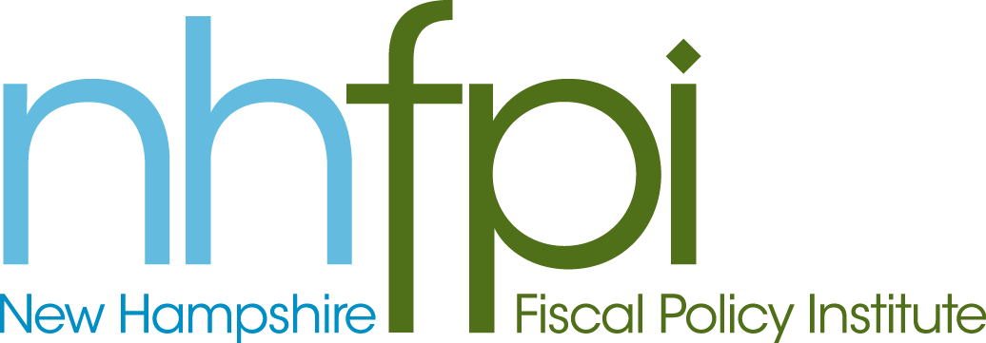
news release

FOR IMMEDIATE RELEASE March 12, 2014
CONTACT AnnMarie French
603.856.8337 x2

NH House Votes to Increase State Minimum Wage

CONCORD, NH – The New Hampshire House of Representatives today by a vote of 173 to 118 approved HB 1403, a bill to increase the state minimum wage to $9.00 an hour over two years and apply cost of living adjustments in future years. New Hampshire’s current minimum wage is $7.25 an hour and the wage has remained at this level since 2008.

“New Hampshire’s current minimum wage leaves workers struggling to get by,” said New Hampshire Fiscal Policy Institute Executive Director Jeff McLynch. “Raising the minimum wage and ensuring it is adjusted for the cost of living in future years would help families make ends meet, boost sales at local businesses, and put New Hampshire on a path towards an economy that works for everyone.”

HB 1403 would increase the minimum wage to $8.25 per hour on January 1, 2015, and to $9.00 per hour on January 1, 2016. Beginning January 1, 2017, it would automatically increase New Hampshire’s minimum wage to account for inflation (based on the Consumer Price Index).

An analysis conducted by the Economic Policy Institute indicates that HB 1403 would either directly or indirectly increase the wages of 76,000 Granite Staters. Of those who would be affected, 72 percent are adults age 20 and older; 32 percent work full-time; 59 percent are women; and 14 percent are parents.

On average, those who would be affected by a $9.00 minimum wage would see their pay go up by $870 per year. As minimum wage workers spend every dollar they earn, this spending will boost the bottom lines of stores, shops, and businesses in communities across the state while adding $64 million to the New Hampshire economy over the next two years.

The WMUR Granite State Poll released on February 6 found that 76% of state residents support increasing the minimum wage to $9.00. The poll question asked respondents if they supported an increase to $8.25 in 2015 and to $9 an hour in 2016. Across the political spectrum, the majority of Democrats (91%), Republicans (64%), and Independents (70%) favored this proposed increase to the minimum wage.
-30-

